UV Health Group Product Spec Sheets

Spec Sheet: Assurance™ SafeAirUV 4’ Fixture

The most powerful UV-C fixture certified to kill COVID-19 and other viruses in the air while people are in the room.

UV Health Group Inc.
Our experienced team of designers, engineers and scientists have developed powerful and effective solutions for clearing airborne viruses, including SARS-CoV-2, the cause of COVID-19, from indoor air. Our patent pending SafeAirUV™ System uses strong UV-C LED lights to inactivate airborne pathogens inside a sealed chamber, out of view of people, providing cleaner and safer air in environments where customers, staff, and residents are present. Businesses, assisted living, hospitals, schools, restaurants and airlines can now invite people to safely enter their environments with confidence that their air is continuously being made safe, slowing the spread of this pandemic, as well as any future virus mutations, the common cold, and all seasonal flus.

Assurance™ SafeAirUV System
The Assurance™ SafeAirUV™ System is designed to continuously cycle room air through its sealed chamber which is filled with arrays of UV-C LED lights, inactivating virtually all viruses offering multiple room air changes per hour. Two Assurance™ SafeAirUV System fixtures will clear all of the air of infectious viruses in an 800-cubic foot room within 20 minutes - then continuously keeping the air free of viruses thereafter. It has been known for many years that UV-C light will inactivate airborne viruses. And the Assurance™ SafeAirUV System utilizes the most powerful germicidal wavelength UV-C LEDs (275nm). This new fixture can be hung or mounted and is perfect for essential gathering places negatively affected by the COVID-19 global pandemic - with the additional benefit of eradicating viruses that cause seasonal flus and the common cold.

Proof through science
Testing results prove efficacy through science - The Assurance™ SafeAirUV System was tested in the fall of 2020 using live aerosolized SARS-CoV-2 virus in a highly controlled environment at the University of Missouri’s Level 3 infectious disease laboratory. Results consistently and conclusively demonstrate that the SafeAirUV System™ inactivates 99.9996% of the infectious doses of the COVID-19 causing viruses in the air in a single pass through the SafeAirUV System.

Research report is available at www.uvhealthgroup.com.

Safe Air Where Life Happens!

Introducing: The Assurance SafeAirUV System
The Assurance SafeAirUV System continuously inactivating airborne viruses. This long-lasting UV-C LED fixture is supported by a mobile app for adjusting, scheduling, monitoring, and maintaining the systems.

Features & Benefits
- Mobile App Support
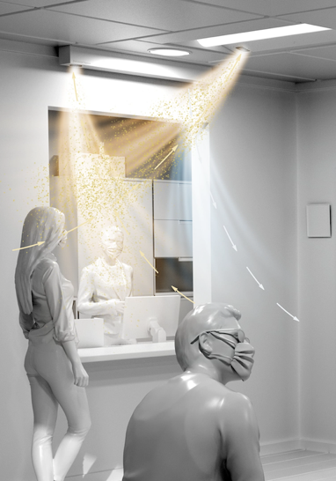
  - Wireless mesh connected
  - Installation & Set up Support
  - Timers & scheduling
  - Motion Sensor
  - Maintenance indicator & notifications
- Allows for wireless grouping of fixtures
- Long-lasting UV-C LEDs (50,000+ hours)
- FDA approval & UL listing (pending)

The SafeAirUV™ System
- Continuously inactivates viruses in air while people are in the room
- Tested & certified to inactivate 99.9996% of all airborne viruses, including SARS- CoV-2 (COVID-19) Report available at www.uvhealthgroup.com
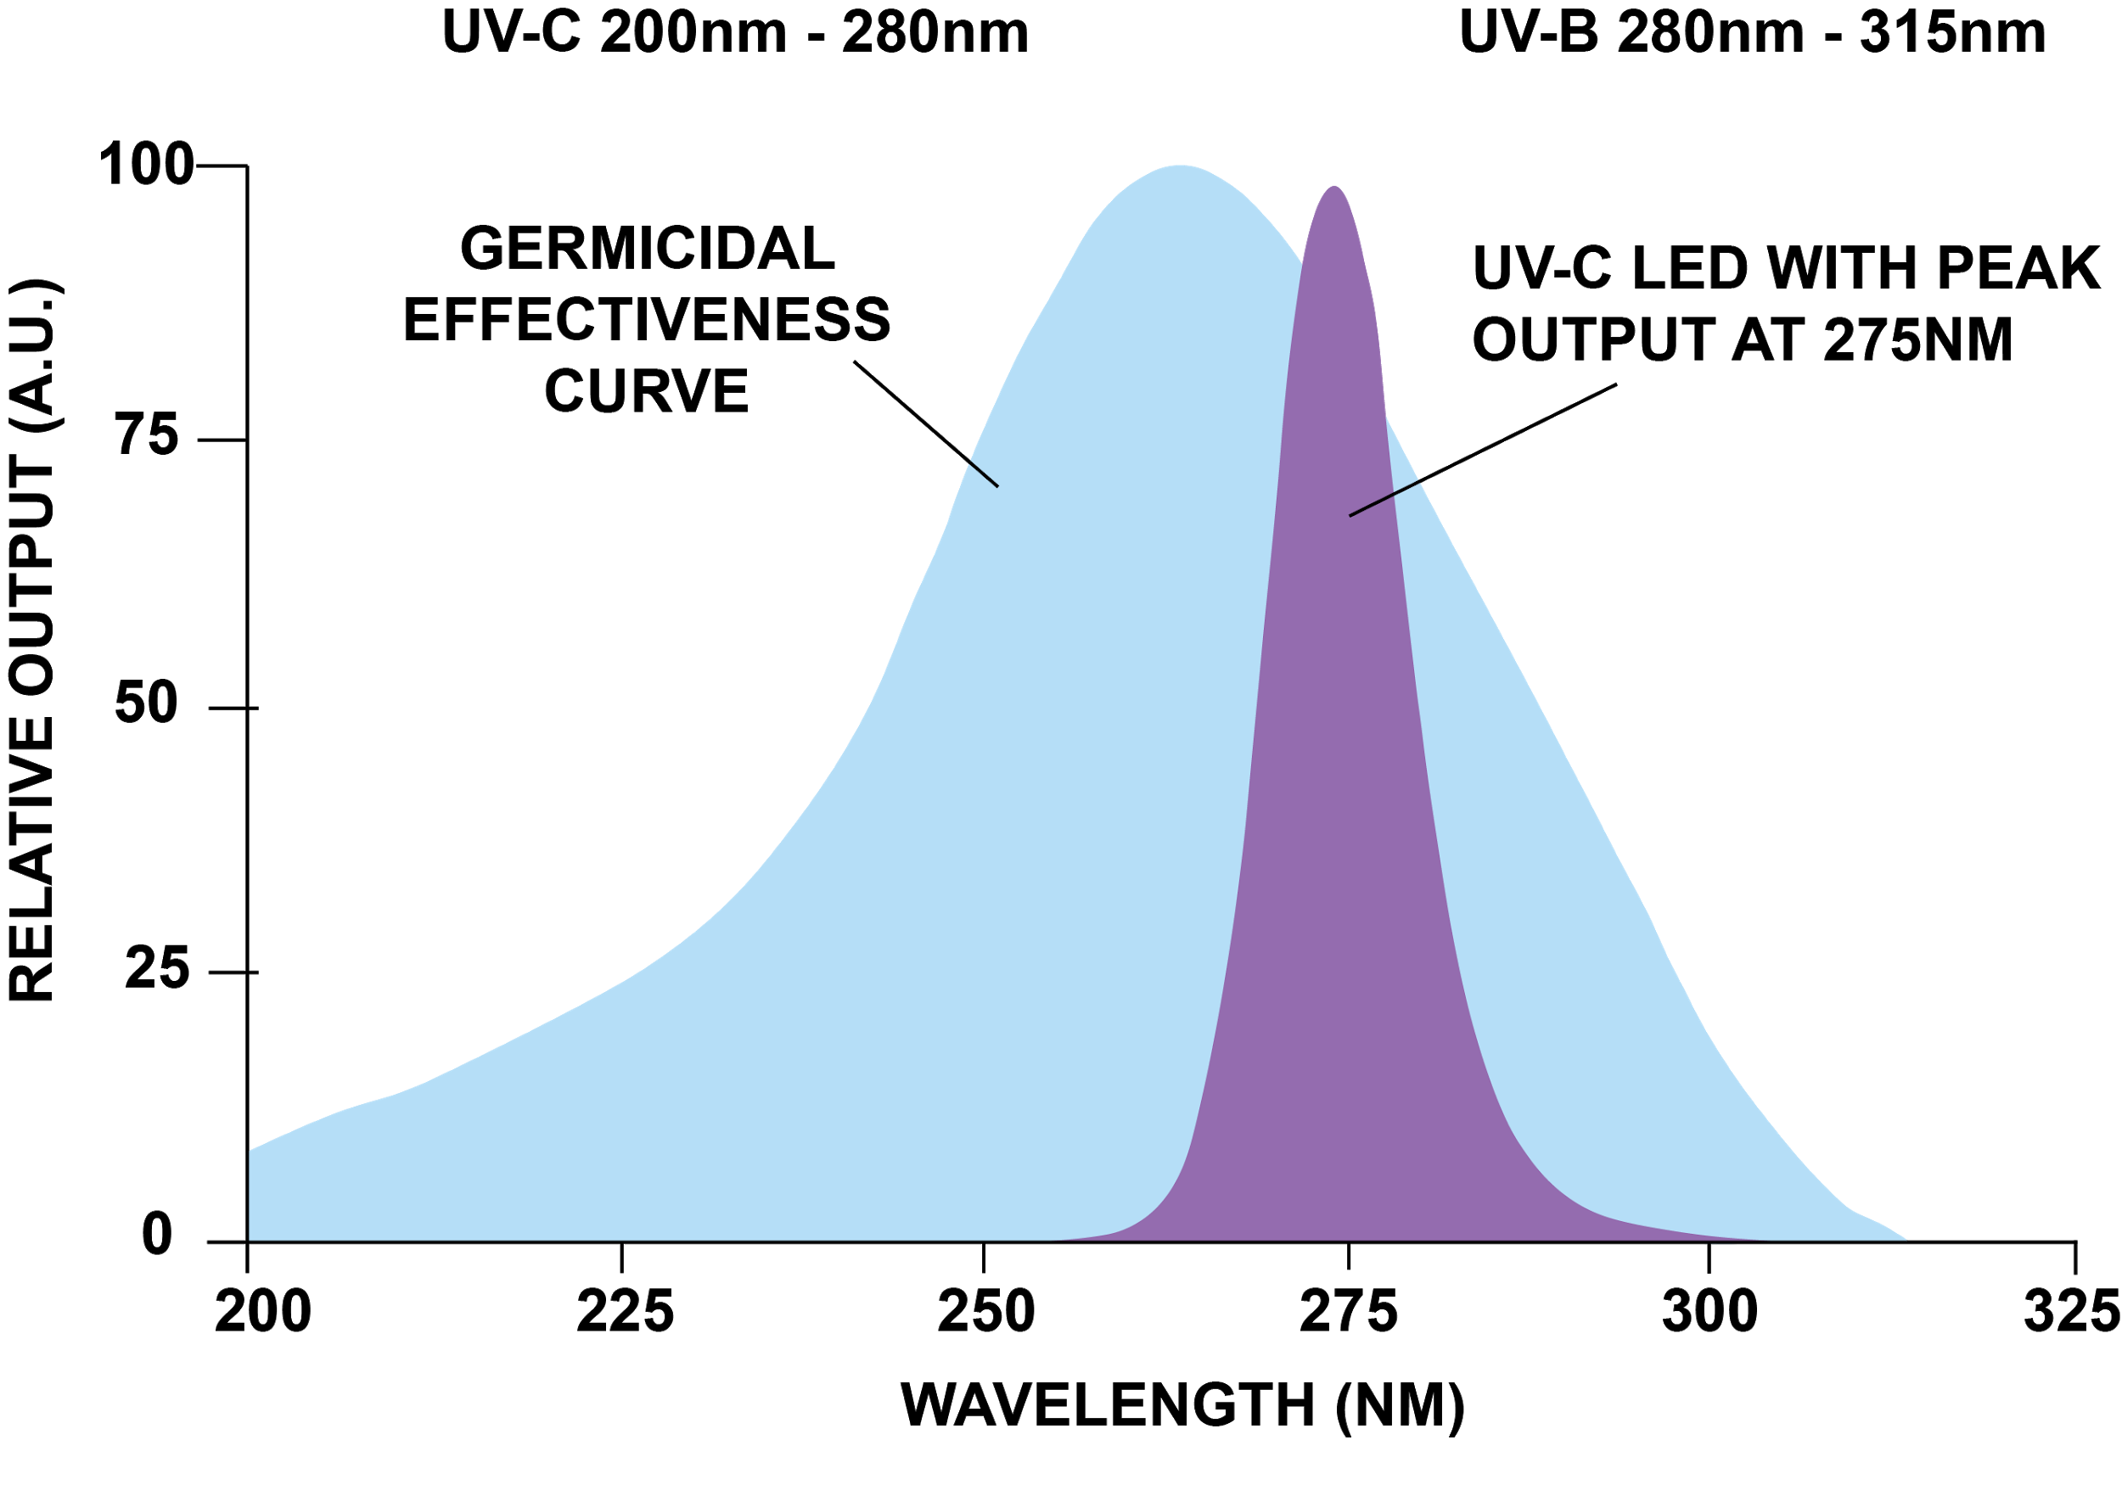
- No Mercury-filled UV-C bulbs to change every 9 months
- Lower cost of ownership with longer life LEDs. 10K+ hours
- Science driven solution using UV-C 275nm
- No UV-C light exposure – ever.
- Designed to process and cleanse all room air multiple times per hour
- Quiet yet powerful variable speed fans
- Airflow adjustments accommodate multiple room sizes/shapes
- UV-C LED maintenance indicator light

Key Advantages
- Inactivates all pathogens in the air, when people are present
- Long life UV-C LEDs, not UV-C mercury bulbs
- Using the most powerful UV-C LEDs (275nm) to inactivate airborne viruses
- Tested in level 3 lab with Live Aerosolized SARS-CoV-2 virus
- Smartphone app to set fan speed, timing & schedules
- Motion sensor enables “room aware” features, knowing when people are present
- Status indicator light
- Self-monitoring maintenance features, using Internet connection with notifications
- UL & FDA approval (pending, Q2 2021)
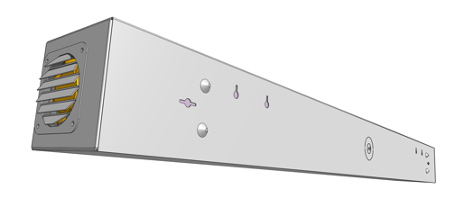
- Hassle-free installation
- 5 Year Warranty

Electrical Requirements Specifications
- Input Voltage: 85 – 305 VAC or 120 – 431 VDC
- Input Voltage Frequency: 47 – 63 Hz
- Input power: 175 W

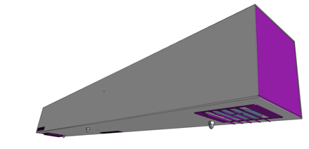
UV-C LED Specifications
- UV-C LED Light Bar Current: Nominal 100 mA DC
- UV-C LED Peak Wavelength: 275 nm ± 5nm
- L70: 50,000+ Hours

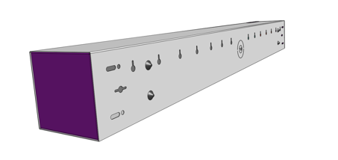

V3.5.2

